Reliability of Radiomic Features Against Noise in the Use of Daubechies Wavelet Derived Features in CT-Based Liver Tumor

Rasyida Shabihah Zukro Aini
Electrical Engineering Department
University of PGRI Adi Buana
Surabaya, Indonesia
Rasyidashabihah@gmail.com

Ira Puspasari
Computer System Department
Dinamika University
Surabaya, Indonesia
ira@stikom.edu

Abstract—There are still many challenges in the field of radiomics, especially sensitivity which is influenced by many factors, one of which is noise. The large amount of bias noise that occurs reduces the performance of the diagnosis, perhaps because it does not involve wavelet derived features. The wavelet derived feature is believed to be more resistant to noise interference in the image. So, the proposed use of wavelet derived features accompanied by a comparative review of its effectiveness with the use of traditional radiomic features is implemented in this study. In this study, two liver tumor datasets were used, namely LiTS17 and 3D-IRCADb-01 data to test the reliability of features in different data. The two data are given the same treatment, namely by adding interference to the CT image by setting the SNR indicator. The label used is limited to the tumor part, the liver parenchyma is not included, so for LiTS17 a thresholding label is done first. CT images and tumor labels extracted data from traditional radiomic features and wavelet-derived radiomic features (Daubechies level 1). The statistical approach uses the ICC method in assessing agreement between observers. As a result, of the six feature groups (First-order, GLCM, GLSZM, GLDM, NGTDM, GLRLM) only NGTDM features are more effective on wavelet derived features. Whereas in the main LiTS17 data, the wavelet derived features do not have a major effect, traditional radiomic features sufficiently show ICC values in the good to excellent category.
Keywords—Radiomic Features, Daubechies Wavelet, White Noise, Liver Tumor.

Introduction
The future development of the medical world is not only based on the diagnosis of a disease, but also individual-based treatment. So that quantitative analysis of big data and the use of Artificial Intelligence (AI) is very often used, including radiology data which generally has image coverage from 2D to 4D. Radiomic is a process used to extract quantitative properties (features) of an image or a certain Region of Interest (ROI) obtained from an image [1]. Through pattern recognition algorithms, these features are extracted producing a series of numbers that represent a quantitative description of geometric or physical properties, such as in the field of oncology, tumors are classified based on size, shape, intensity and texture.
However, one of the biggest challenges in radiomics is sensitivity. There are many influencing factors including image acquisition, reconstruction, and pre-processing. Other things that also influence are the segmentation results in the part being reviewed and noise interference which reduces image sharpness. The findings of A. Somasundaram et al stated that the Positron Emission Tomography (PET) image acquisition modality is a modality that is sensitive to noise, due to the low Signal-to-Noise Ratio (SNR) which not only affects the precision but also the accuracy of quantitative metric results, thereby biasing the results. due to noise [2]. Meanwhile, another modality that is commonly used as a standardized modality in cancer management, namely computerized tomography (CT), also has weaknesses related to noise. Hassan et al in testing the radiomic features of head/neck cancer provided evidence that almost all types of features, namely Laws' Texture Information (LAWS), Long Gray Level Run (GLRL), Intensity Based Histogram (IBHF), Two-Dimensional Wavelet Transform ( 2DWT), and Two Dimensional Gabor Filter (2DGF) are also affected by noise (especially the Gaussian type which has a cut-off frequency greater than the Nyquist frequency) [3]. Another study involving CT modality, namely from our previous study, related to the analysis of radiomic features in the diagnosis of liver tumors with different segmentation ROI [4]. There is a weakness in the small accuracy results on some ROIs, this is thought to be due to the use of radiomic features without wavelet features.
The wavelet feature is believed to be more resistant to image noise. Through the use of wavelet scattering radiomic features as compared to using only traditional radiomic features, the prediction results of glioma ratings can be improved by 13% [5]. Another study [6] mentioned the use of wavelet transform-based radiomic textures in estimating Pathological Complete Response (pCR) which showed no residue in breast tissue after surgery, wavelets gave better results than no small waves in radiomic texture analysis.
In an effort to evaluate our previous work [7], based on the fact that wavelets can improve yield in radiomic analysis, this study aims to identify the reliability of involvement of wavelet features in the diagnosis of liver tumors. This work is designed by adding noise to the dataset, then performing feature extraction using or without using radiomic features. The final step is to compare the SNR and Intraclass Correlation Coefficient (ICC) to prove the reliability of the wavelet features in the data. Testing was also performed on CT-based liver tumor data from other sources to test the unbiased reliability of the wavelet features.

Methods

Dataset of Liver Tumor
The data used are liver tumor data with computed tomography (CT) modality tested in two publicly available dataset groups namely Liver Tumor Segmentation Challenge (LiTS17) [8] and 3D Image Reconstruction for Algorithmic Database Comparison (3D-IRCADb-01) [9].
The first data, LiTS17 as in previous studies [7] consisted of 130 subjects from various types of liver tumors, ranging from primary tumors such as HCC and secondary tumors as well as metastases originating from colorectal, breast and lung cancer. Images were acquired from a variety of CT modalities and acquisition protocols. The number of tumors varied from 0 to 12. The actual data label consisted of the liver parenchyma and tumor sections. In this study, restrictions were applied to using only the first 20 subjects and tumor labels only to prevent bias towards the second data to be used as test-retest data.
The second data, 3D-IRCADb-01 consisted of 20 subjects, 10 women and 10 men with a percentage of 75% suffering from liver tumors. The labels in this data are only part of the tumor. The two data did not go through the pre-processing stage at all, so the review was only focused on adding disturbances.

Noise Additional
CT images is added by noise namely White Noise. White noise is represented in random signals that have the same intensity at different frequencies, so the power density is constant. In the field of image processing, noise pixels are obtained in a rectangular grid arrangement with a uniform probability distribution over several intervals. In its design, the use of white noise is adopted from the “python-acoustics” package which has specifications of a two-fold increase in power per spectrum band or an increase of 3 dB per octave.
SNR 30% SNR 50% SNR 80% SNR 90% Original
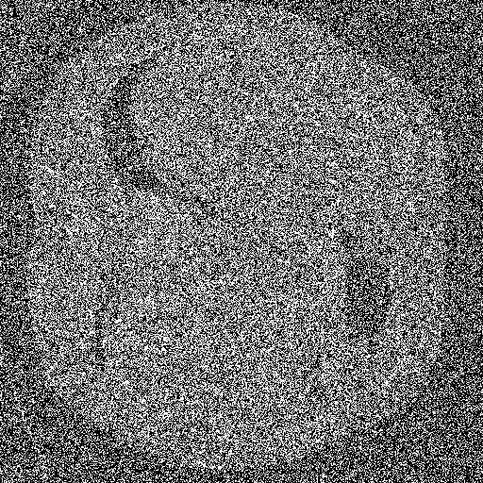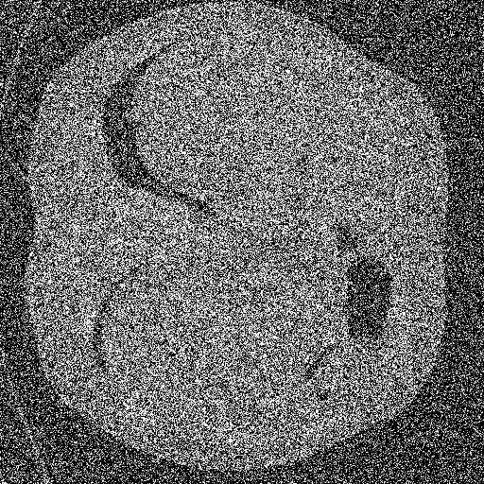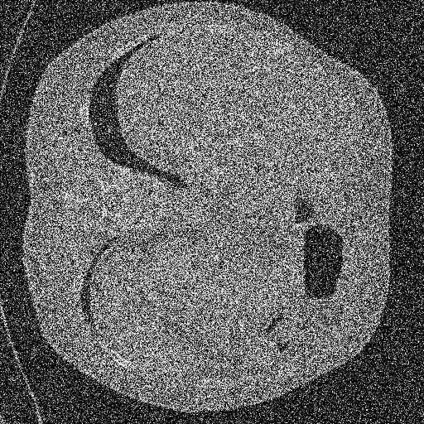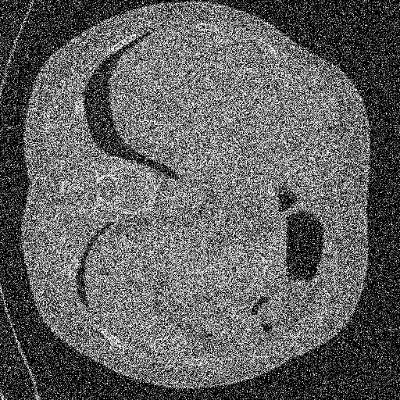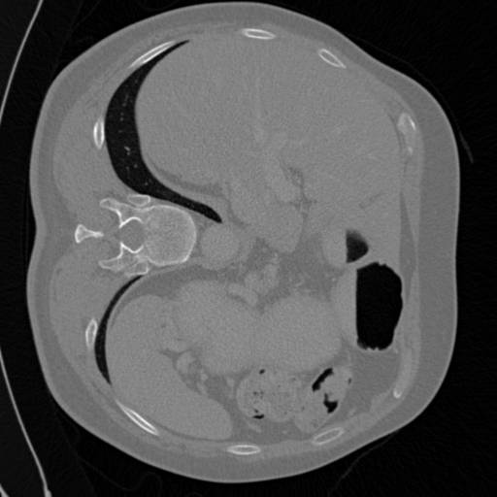

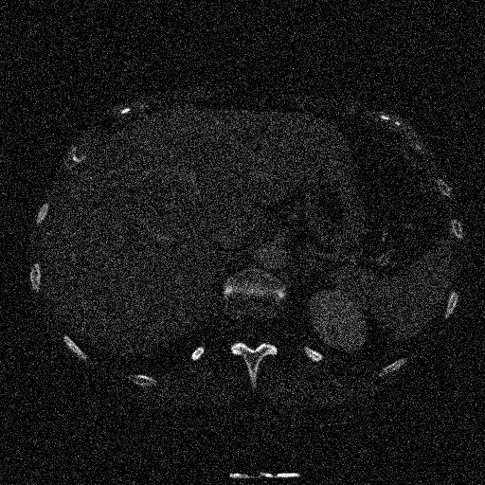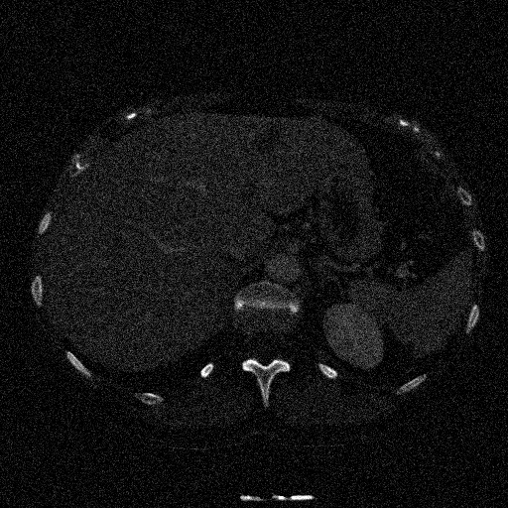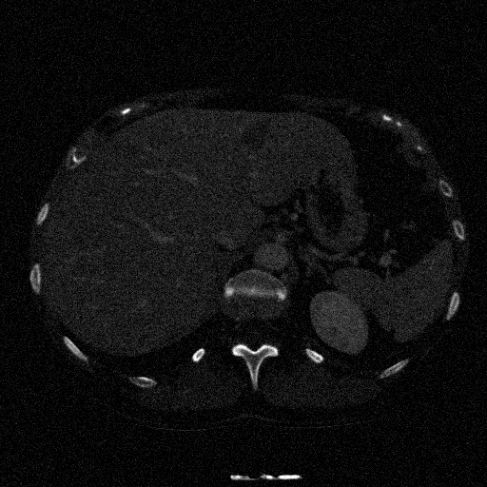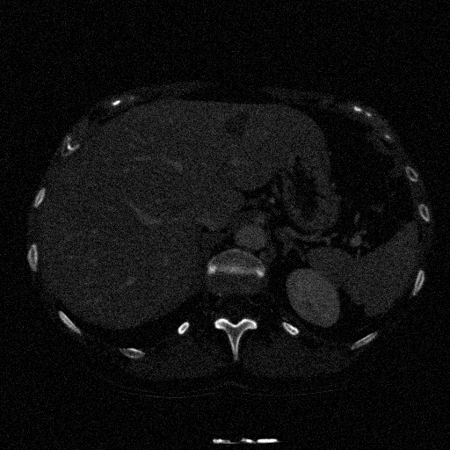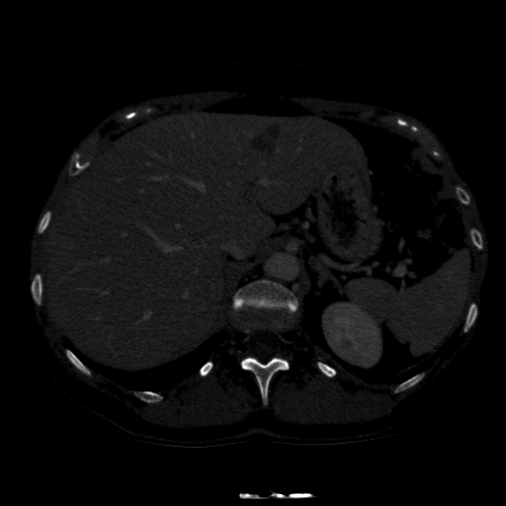
Fig.1. Visualization of LiTS17 (top) and 3D-IRCADb-01 (bottom) data images with interference levels according to their respective SNRs.
To assess image reliability at several noise levels, noise testing was determined with SNR levels of 30%, 50%, 80% and 90%. Fig. 1. shows the shape of the noise in each CT image. SNR is a form of comparison between signal level and background noise level. A high SNR value means the image signal is clearer and easier to characterize, while a low SNR value means the signal is unclear or covered by noise and difficult to characterize. SNR can generally be calculated via Equation (1) or (2). Because the type of noise used is white noise, the correct form for determining SNR is Equation (3).
$SNR= \frac{P_{signal}}{P_{noise}}={\left(\frac{A_{signal}}{A_{noise}}\right)}^{2}$ (1)

$SNR= \frac{μ}{σ}$ (2)

${SNR}_{white noise}= \frac{\int{s^{2}\left(t\right)dt}}{N_{0}/2}$ (3)

with $P_{signal}$ is average power signal and $A_{signal}$ is root mean square (RMS) amplitude of signal, both also applied in noise. $μ$ is signal mean and $σ$ is standard deviation of the noise. $s$ is signal and $N_{0}/2$ is the spectral height of the white noise and corresponds to the value of the noise power spectrum at all frequencies.

Tumor Segmentation
LiTS17 data has two types of labels, namely liver parenchyma labels and tumor labels in one image, therefore an effort was made to obtain the Region of Interest (ROI) of the tumor by applying semi-automatic segmentation using the "cv2.findcontours()" package only to the tumor part. The tumor part was identified as having the highest intensity, namely 255, so the image intensity thresholding algorithm was used. The tumor segmentation process does not apply to 3D-IRCADb-01 data because the labels are correct.

Radiomic Features
The open-source package “Pyradiomics” [10] is used in the feature extraction step of 3D CT images with tumor labels. These radiomic features are divided into 18 first-order features, 75 texture features which are divided into 24 Gray Level Cooccurrence Matrix (GLCM) features, 16 Gray Level Run Length Matrix (GLRLM) features, 16 Gray Level Size Zone Matrix (GLSZM) features, 14 the Gray Level Dependence Matrix (GLDM) feature, as well as at least 5 features of the Neighboring Gray Tone Difference Matrix (NGTDM).
93 features with original image filters or also known as traditional radiomic features, when converted into wavelet derived features, the number increases to 744. Wavelet transformation works by decomposing local intensity into two frequencies, namely low and high. The decomposition process is applied in low-pass filter (known as a scaling function with the symbol L) and a high-pass filter (also known as a wavelet function with the notation H) in each direction. That the total filters resulting from wavelet decomposition are 8 filters for each feature in a three-dimensional image (composed of a combination of three L or H in each direction) [11].
This feature group is not only applied to the original features but also to the derived wavelet features. The type of wavelet used is Daubechies level 1 (db1). The Daubechies wavelet has a lot in common with Haar, but there are some differences with Haar, i.e. for the Daubechies wavelet transform, the signal and wavelet scaling have slightly longer support, i.e. they generate the average and difference just by using some additional values of the signal. It is very effective at compression and noise reduction tasks for both audio and picture signals. So that at the same signal, the Daubechies wavelet is superior to Haar [12].

Statistical Analysis
Determination of class correlation in data that aims to determine the character of reproducibility is used Intraclass Correlation Coefficient (ICC). For the first and second data, we devised the ICC calculation for the investigation of agreement among raters so the model we used is the two-way random effects model Analysis of Variance (ANOVA), absolute agreement, single rater/measurement, also called ICC (2, 1), the calculation as follows:

$ICC\left(2,1\right)=\frac{{MS}_{R}-{MS}_{E}}{{MS}_{R}+(k+1){MS}_{E}}+\frac{k}{n}\left({MS}_{C}-{MS}_{E}\right)$ (4)

with ${MS}_{C}$ is mean square for columns, ${MS}_{R}$ is mean square for rows, ${MS}_{E}$ is means square error, $k$ and $n$ show number of observer and the participant involved.
According to Koo and Li [13] the ICC interpretation results for inter-rater agreements are divided into 4 groups:
- Poor Reliability: ICC < 0,5
- Moderate Reliability: 0,5 ≤ ICC < 0,75
- Good Reliability: 0,75 ≤ ICC < 0,9
- Excellent Reliability: ICC ≥ 0,9

Results and Discussion
Radiomic features obtained from segmented tumors which then go through an extraction process consisting of First-Order feature groups, GLCM, GLRLM, GLSZM, GLDM, and NGTDM are assessed for reliability by testing with or without wavelets against noise interference. The specified noise consists of four different levels. Testing was also performed on other data similar to clinical evidence of liver tumors to validate the feature's reliability against other data. The instrumentation used in testing feature reliability is the Intra-class Correlation Coefficient (ICC).

Robust Features Test in Various SNR
Comparison of original Pyradiomics filter features with Wavelet Daubechies filter level 1 at SNR 30%, 50%, 80%, 90% applied to LiTS data. From 20 subjects, only 16 subjects had tumors. The ICC (2,1) radiomic features of the tumor are presented in Fig. 2 to Fig. 5.
The feature groups in this data prove to be reliable for almost all features, except for the GLSZM feature which is unreliable with 80% noise addition. The feature group that has the highest reliability is GLCM and is included in the good agreement category, while the db1 wavelet derivative can improve the reproducibility of NGTDM features. It is also seen here that the SNR level does not affect the increase or decrease in the correlation.

- Graph of feature reliability from LiTS data with the addition of the 30% SNR noise parameter.

- Graph of feature reliability from LiTS data with the addition of the 50% SNR noise parameter.

- Graph of feature reliability from LiTS data with the addition of the 80% SNR noise parameter.

- Graph of feature reliability from LiTS data with the addition of the 90% SNR noise parameter.

Robust Features on Another Data
Other liver tumor data used as test-retest data in assessing the reliability of radiomic features against noise is 3D-IRCADb-01. With features extracted in tumor sections and subjected to the same interference treatment as in the LiTS data. From 20 available subjects, 15 subjects were found to have tumor labels. The results of the feature reliability assessment were carried out using ICC2, the assessment was focused on reviewing reliable feature groups and filter types.
Table I shows that only the NGTDM texture feature group is quite reliable or is in the moderate category at almost all SNR levels. NGTDM is dominated by higher ICC values using wavelet derived features than without wavelets. While the second data is very different from the first data. There is no relationship between an increase in SNR and an increase in ICC values in this data. Apart from NGTDM, no feature group can be considered reliable. This may be because the original image without added noise is too dark, making it difficult to identify first-order features and other texture features.
For further research, it is recommended to carry out similar pre-processing stages for all data. For the second method, it is possible to track the type of mother wavelet and the level that has the highest performance. Wavelet Daubechies may be better than Haar, but not better than Symlet or Biorthogonal [11]. This can also be proven through performance in machine learning models such as research conducted by Prinzi et al [14].
- ICC 3D-IRCADb-01 on Original Radiomic Features and Wavelet Derived Features
Data | Feature Cohort | ICC of Original Feature | ICC of Daubechies Wavelet Features
Noise additional with SNR 30% | firstorder | 0.352 | 0.341
Noise additional with SNR 30% | GLCM | 0.400 | 0.300
Noise additional with SNR 30% | GLRLM | 0.355 | 0.341
Noise additional with SNR 30% | GLSZM | 0.342 | 0.332
Noise additional with SNR 30% | GLDM | 0.355 | 0.337
Noise additional with SNR 30% | NGTDM | 0.630 | 0.336
Noise additional with SNR 50% | firstorder | 0.351 | 0.341
Noise additional with SNR 50% | GLCM | 0.457 | 0.213
Noise additional with SNR 50% | GLRLM | 0.355 | 0.340
Noise additional with SNR 50% | GLSZM | 0.341 | 0.327
Noise additional with SNR 50% | GLDM | 0.360 | 0.337
Noise additional with SNR 50% | NGTDM | 0.020 | 0.379
Noise additional with SNR 80% | firstorder | 0.351 | 0.341
Noise additional with SNR 80% | GLCM | 0.353 | 0.211
Noise additional with SNR 80% | GLRLM | 0.357 | 0.340
Noise additional with SNR 80% | GLSZM | 0.342 | 0.328
Noise additional with SNR 80% | GLDM | 0.369 | 0.339
Noise additional with SNR 80% | NGTDM | 0.481 | 0.551
Noise additional with SNR 90% | firstorder | 0.351 | 0.341
Noise additional with SNR 90% | GLCM | 0.366 | 0.193
Noise additional with SNR 90% | GLRLM | 0.358 | 0.340
Noise additional with SNR 90% | GLSZM | 0.337 | 0.329
Noise additional with SNR 90% | GLDM | 0.370 | 0.339
Noise additional with SNR 90% | NGTDM | 0.304 | 0.582

Conclusion
Wavelet derived features, in this scope Daubechies level 1 type is used for noise interference added to the radiomic features of liver tumors which indicates that this type of wavelet derived feature is only able to increase the reliability of one group of features, namely the NGTDM texture features. The comparison results between using radiomic features with original image filters and using derived wavelet features state that the derived wavelet features do not have a big influence on LiTS17 data, many original features also produce higher ICC features in groups other than NGTDM. This cannot be validated with data support because the intensity of the supporting data image before the disturbance is not good.

References
[1] A. S. Tagliafico, M. Piana, D. Schenone, R. Lai, A. M. Massone, and N. Houssami, “Overview of radiomics in breast cancer diagnosis and prognostication,” Breast, vol. 49, pp. 74–80, 2020, doi: 10.1016/j.breast.2019.10.018.
[2] A. Somasundaram et al., “Mitigation of noise-induced bias of PET radiomic features,” PLoS One, vol. 17, no. 8 August, 2022, doi: 10.1371/journal.pone.0272643.
[3] G. Palareti et al., “Comparison between different D-Dimer cutoff values to assess the individual risk of recurrent venous thromboembolism: Analysis of results obtained in the DULCIS study,” Int. J. Lab. Hematol., vol. 38, no. 1, pp. 42–49, 2016, doi: 10.1111/ijlh.12426.
[4] H. Bagher-Ebadian, C. Liu, F. Siddiqui, B. Movsas, and I. J. Chetty, “On the Impact of Smoothing and Noise on Robustness of CT and CBCT Radiomics Features for Patients with Head and Neck Cancers,” Int. J. Radiat. Oncol., vol. 99, no. 2, p. S93, 2017, doi: 10.1016/j.ijrobp.2017.06.225.
[5] Q. Chen, L. Wang, L. Wang, Z. Deng, J. Zhang, and Y. Zhu, “Glioma Grade Prediction Using Wavelet Scattering-Based Radiomics,” IEEE Access, vol. 8, pp. 106564–106575, 2020, doi: 10.1109/ACCESS.2020.3000895.
[6] J. Zhou et al., “Predicting the response to neoadjuvant chemotherapy for breast cancer: Wavelet transforming radiomics in MRI,” BMC Cancer, vol. 20, no. 1, pp. 1–10, 2020, doi: 10.1186/s12885-020-6523-2.
[7] R. S. Z. Aini, “Digilib ITB.” https://digilib.itb.ac.id/index.php/gdl/view/68643 (accessed May 12, 2023).
[8] P. Bilic et al., “The Liver Tumor Segmentation Benchmark (LiTS),” no. January, 2019, [Online]. Available: http://arxiv.org/abs/1901.04056.
[9] L. Soler et al., “3D Image Reconstruction for Comparison of Algorithm Database: a Patient-Specific Anatomical and Medical Image Database,” p. 67091, 2010.
[10] J. J. M. Van Griethuysen et al., “Computational radiomics system to decode the radiographic phenotype,” Cancer Res., vol. 77, no. 21, pp. e104–e107, 2017, doi: 10.1158/0008-5472.CAN-17-0339.
[11] M. Soufi, H. Arimura, and N. Nagami, “Article Type: Research Article Identification of optimal mother wavelets in survival prediction of lung cancer patients using wavelet decomposition-based radiomic features,” doi: 10.1002/mp.13202.
[12] Y. Meyer, “Chapter 2 Daubechies wavelets.”
[13] T. K. Koo and M. Y. Li, “A Guideline of Selecting and Reporting Intraclass Correlation Coefficients for Reliability Research,” J. Chiropr. Med., 2015, doi: 10.1016/j.jcm.2016.02.012.
[14] F. Prinzi, C. Militello, and V. Conti, “Impact of Wavelet Kernels on Predictive Capability of Radiomic Features : A Case Study on COVID-19 Chest X-ray Images,” 2023.

